Brainstorming
While field basing in a third grade general education classroom my cooperating teacher and I recognized that our students were having significant problems putting a story into their own words on paper. To solve this problem I created a Brainstorming sheet that could be used for any story or essay they would encounter over the years.
The worksheet I designed can be modified to work in any classroom setting and at any grade level. The concept of a 5 paragraph essay is not even addressed in 3rd grade, but all of my students were able to create a quality essay with the use of this organizer.
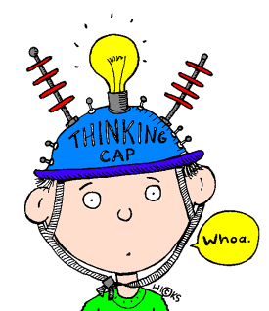
Brainstorming
Write a Grabber sentence and your Summary sentence.
Paragraph 1: Introduction
Grabber:__________________________________________
____________________________________________________.
Summary:______________________________________________________________________________________________________________________________________________________.
Write your main idea for each paragraph and two supporting details.
Paragraph 2: Main Idea 1
Main Idea: _____________________________________________
___________________________________________________________________________________________________________________.
Detail 1:____________________________________________________
___________________________________________________________________________________________________________________.
Detail 2:____________________________________________________
___________________________________________________________________________________________________________________.
Paragraph 3: Main Idea 2
Main Idea: ___________________________________________________________________________
___________________________________________________________________________________________________________________.
Detail 1:____________________________________________________
___________________________________________________________________________________________________________________.
Detail 2:____________________________________________________
___________________________________________________________________________________________________________________.

Paragraph 4: Main Idea 3
Main Idea: _____________________________________________
___________________________________________________________________________________________________________________.
Detail 1:____________________________________________________
___________________________________________________________________________________________________________________.
Detail 2:____________________________________________________
___________________________________________________________________________________________________________________.
Write your summary sentence that you used in the introduction and a closing sentence
Paragraph 5: Conclusion
Summary:__________________________________________________________________________________________________________________________________________________.
Closing:_______________________________________________________________________________________________________________________________________________________.

